RWY12 Object Placer v1.2– Frequently Asked Questions
Aug. 2005

This document supplements the RWY12 Tutorial. It is not intended to replace it.
It is designed to assist those who are interested
in trying the program and/or who may be
experiencing some difficulties.

Contents

Section A What is the RWY12 Object Placer Program?

Section B What do I need to download and where can I find it?

Section C How do I install the program?

Section D How do I add objects?

Section E What are some of the common problems?

Section F How do I add additional libraries to the basic program?

Section G Are there any other Tutorials and/or help available?

Section A

Question: Just what is the Rwy12 Object Placer program?

Answer: Rwy12 Object Placer v1.2 is a freeware program for placing static library objects in FS2004 in a simple and quick way. No need for scenery programming knowledge. To use it you just open FS2004 at the place you wish to add objects, (airport or just your neighborhood). Open Rwy12, which is synchronized with FS2004, and choose your objects from a library that has over 1,000 default and new objects in this version. The program is open ended and many other scenery developers have added and are continuing to add their creations to the library. The program was created by Israel Roth and Seev Kahn.

The program is not a scenery “creator” in the sense that you actually create new objects. In the most basic terms, it is used only to place scenery objects that will enhance your existing scenery.

Just a few of the objects now available include jetways, vehicles, hangers (some with animated doors), hot air balloons, airport ramp accessories, aircraft, trees, people, tents, birds and more, plus all of the default objects you see in FS2004.

Section B

Question: Ok, I want to give it a try – what do I need to download and where can
I find it?

Answer: You will need to download the Rwy12 Object Placer V1.2 Program with all it’s libraries plus three additional programs that are required for the program to work.

The basic program is called rwy12_Program_v1.2.zip and is available at Avsim.com and Flightsim.com (with a different name – so search for it in the download section).
In addition to the basic program you will have to download the 39 object libraries (with over 1,000 objects), already existing to date. Because of the total size of the libraries they are divided into three downloads;
rwy12_Lib1_v1.2.zip
rwy12_Lib2_v1.2.zip
rwy12_Lib3_v1.2.zip

New object libraries are contributed from time to time, so please follow up the major download sites for those additions.

The other required programs are:

1. FSUPIC – by Pete Dowson. As of this writing, the latest version of this free program is Ver. 3.47. You can find this at Avsim.com or Flightsim.com or you can download it directly from the author’s site by following this link:

http://www.schiratti.com/dowson.html

2. Microsoft's MSXML4. You can download this program from Microsoft download center.

http://www.microsoft.com/downloads/details.aspx?FamilyID=3144b72b- b4f2-46da-b4b6-c5d7485f2b42&displaylang=en

You need to download and install only the msxml.msi file (5,166 kb). You will find the file at the end of the download page. (The program is language sensitive, so choose your O\S language first).

3. Microsoft's Dotnetfx NET framework. The 23,698 kb program can be downloaded directly from Microsoft Download Center.

http://www.microsoft.com/downloads/details.aspx?FamilyID=262d25e3-f589-4842-8157-034d1e7cf3a3&DisplayLang=en

You will be downloading a program named dotnetfx.exe.

Just click on the “download” bar at the top right of the screen.

(The program is language sensitive, so choose your O\S language first).

All of these downloads should be saved in a temporary folder of your choice. If you wish, this temporary folder can be on your desktop.

Section C

Question: Ok, I have downloaded all of the above programs, how do I install them?

Answer: The first thing to do is sit back, take a deep breath, get a cup of coffee and relax. Most of the problems users have, stem from being in too much of a hurry when installing the program. So take it slow and easy from this point forward. Taking a few extra minutes to read and follow, to the letter, all instructions, will save you hours of frustration.

With ANY major installation, it is wise to create a “restore point” before proceeding.

Most likely you will not need it, but it will be a life saver if you should happen to really mess up your system. This presumes you are using XP as your operating system. So take a few minutes and do it now before proceeding to step 1.

(You may wish to defragment your hard drive at this time also)

Step 1. Create a new folder within the folder where you placed all the files you downloaded. Name this new folder FSUIPC. Move the FSUIPC zip file into this new folder and unzip it. You will see 13 or 14 files when it is unzipped.

There is only one file that we are interested in and that will be named FSUIPC.dll.

This file is to be copied to your Modules folder. The typical path would be:

C:\Program Files\Microsoft Games\Flight Simulator 9\Modules

Please note: You may already have the fsuipc.dll file installed. Replace it ONLY if this one is newer than the one you have. If you already have a registered copy of fsuipc, do not replace it unless you have your registration information handy as you will need to re-enter it. You do not need to register fsuipc in order to have it work with the RWY12 program, but we hope you will seriously consider registering the program to unlock all of the features it has to offer

The newest version of fsuipc is preferred however, as it has been optimized to work with the updated version of FS2004.

Get another cup of coffee.

Step 2. Double click on the msxml.msi program file. This will automatically install the program on your computer. After it has finished, proceed to the next step.

Step 3. Double click on the dotnetfx.exe program file. This will also automatically install the program on your computer.

Please note: It is possible that you already have one or both programs listed in steps 2 and 3 on your computer. If you do, the install routines will not allow a second copy to be installed and you may get an advisory message to that effect. If you already have them, just proceed to the next step.

At this point you should “restart” your computer just to insure that the new programs have been recognized by your operating system.

Get another cup of coffee.

Step 4. We will no longer need the fsuipc.zip, msxml.msi and dotnetfx.exe files but I would strongly recommend that you move them to a safe storage area. That way they will be easily available if you ever need to re-install them. So go ahead and move them now so all you have left in your temporary folder is the four RWY12 zip files.

Step 5. Unzip the rwy12_program_v1.2 file – be sure you have the “use folders” option checked before you begin the unzipping process.

After it is unzipped, you should see a folder named Rwy12 Object Placer v1.2. Within that folder will be the following subfolders and files:

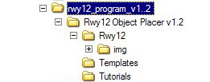

Step 6. Copy and then paste the entire “Rwy12 Object Placer v1.2” folder into your C:\ drive. Please verify that it resides on your C:\ drive as a separate folder. The .doc and .txt files may be placed in this folder also or kept separately somewhere else.

If you have copied and pasted the “Rwy12 Object Placer v1.2” folder correctly, it will appear in a manner similar to this screen shot.

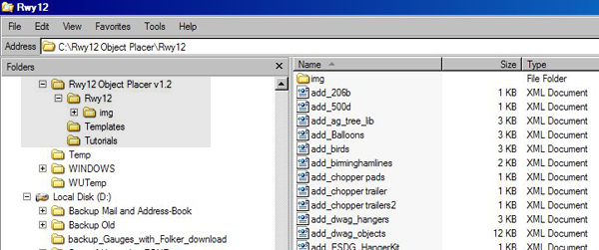

You may safely delete the .jpg, .gif and .diz files at this point.

Step 7. Unzip the rwy12_lib1_v1.2 file – be sure you have the “use folders” option checked before you begin the unzipping process.

After it is unzipped, you should see two folders; a Documentation folder and the static objects #1 basic library folder named Static Objects Library. Within that folder will be the following subfolders: Scenery and Texture.

Now, using the “copy and paste” method, copy the entire “Static Objects Library” folder and paste it into your FS2004 Addon Scenery folder. The typical path to that folder is:

C:\Program Files\Microsoft Games\Flight Simulator 9\Addon Scenery

This is the folder where the RWY12 program “expects” to find the Static Objects and its associated Scenery and Texture subfolders. Please verify that this folder and subfolders are indeed in your Addon Scenery folder and did not get accidentally pasted elsewhere.

Step 8. Now, after you created the basic program and library, you have to add the contents of the other two library folders (#2 and #3) to your object library. Unzip both files; rwy12_lib2_v1.2 and rwy12_lib3_v1.2. When you look at the folders of those libraries you will see that you have in each two folders; Scenery files and Texture files. Paste and copy the files (not the folders!!!) into the just created Static Objects Library;

Scenery files into C:\Program Files\Microsoft Games\Flight Simulator 9\Addon Scenery\Static Objects Library\scenery

Texture files into C:\Program Files\Microsoft Games\Flight Simulator 9\Addon Scenery\Static Objects Library\texture

You may be asked to overwrite some texture files. Please do so.

Step 9. Navigate back to your desktop (if you are not already there) and create a new shortcut by right clicking anywhere on the screen and selecting NEW and then SHORTCUT. This shortcut will be to the ObjectPlacer.exe file which is in the RWY12 folder that you just placed on your C:\ drive. After browsing to the location and selecting the .exe file, name the shortcut RWY12 Object Placer.

As you will often want to view the contents of your Static Object Library/Scenery folder, it is wise to make a shortcut to that subfolder also. Give the shortcut a name that will indicate it leads to that subfolder.

After you have verified that you have copied the Static Objects Library folders and the RWY12 folder to their proper locations, you may delete those folders in your temporary folder. The RWY12 “zip” file should now be placed in a safe storage area in case it is needed in the future.

Ready for another cup of coffee?

There is one more step that needs to be done and this is vital! The program will not work if this step has not been completed!

Step 10. You must “activate” the Static Objects Library folder that you placed in your Addon Scenery folder. This is done just as you would activate any scenery addition. It is actually a “virtual” or “reference” scenery.

Start FS2004. Select Settings then select Scenery Library then select add. Browse to your addon scenery folder and highlight the Static Objects Library and click on it. It should be added to the scenery listings. Be sure there is a check mark in the box in front of the entry. Then select OK. Now exit FS2004. The next time you start FS2004, the program will see this new entry and index its files accordingly.

This would be a good time to review what you have done and double check to see that the various folders are in their correct locations and that your new shortcuts do work. The RWY12 shortcut should bring up the user interface – but we are not quite ready to make use of it. For now, just check to see that it does display.

Section D

Question: O.K. – you made me go through all of that – now how do I use the program?

Answer: The first and most important thing to do is to locate the Rwy12 Object Placer V1.2 Tutorial.doc file and read the first part of it thoroughly – the latter part which deals with changing tail numbers can be saved for a later time. This .doc file is found in the Rwy12 Object Placer v1.2/Documentation folder. The tutorial gives very specific instructions regarding how to place the available objects.

Assuming you have read the Tutorial, the following is the basic procedure to follow.

Start FS2004

Select a small aircraft such as a Cessna and go to the area (an airport usually) that you wish to enhance.

Using the “slew” commands, position your aircraft where you wish to place an object.

Minimize FS2004 (to conserve memory)

Open the RWY12 program using your new shortcut.

Before you do anything else, use the “Save As” command.

This will bring up the screen asking you to name the file you are about to save.

We are going to be saving a file that will have an .xml extension.

Give the file a name you can easily find later.

Example: Opa_hangers_KDAL (the program will add the .xml extension)

Pay close attention to how you name the file – spaces between words are NOT allowed. Use underscores as in the example above.

You can use whatever naming system you wish but it is a good idea to have the name somewhat describe what you have added. Hangers could be grouped in one file while jetways might be in another and lighting etc. might be in yet another.

In the above example, a name has been used (Opa), followed by a description (hangers) and ending with the airport’s ICAO code letters (KDAL).

After you have named the file, hit save. You have just saved a “blank” xml file and are ready to begin adding objects to it.

Note: The idea of saving a “blank” .xml file first is not specified in the Tutorial that comes with the RWY12 program. However, many users have found that doing this helps to make the entire .bgl creation process more efficient.

Now select which object you wish to add from the choices on the drop down menu. Most objects will use a scale of 1.00. The notable exception are the jetways which require a .4 scale. Be sure to check the scale before adding an object.

Click on “sync FS position”. This will place the coordinates for the object in the latitude and longitude and heading boxes. Unless the object is to be suspended in the air, leave the altitude at 0.

Select add – and the object will be added to the list.

Many users now select “save” or “save as” after adding each object and have the original blank file overwritten each time.

You may add as many objects (one at a time) as you wish – however if you are just starting to use the program it is recommended that you try to add only one or two until you are comfortable with the commands.

When you are finished adding objects, use the “save” or “save as” command one last time, overwriting the original file. Then hit the “generate scenery” tab. This will create a file by the same name as your xml file but it will have a .bgl extension. The .bgl file is in a form that can be used (read) by FS2004.

Using the example above, the new .bgl file would be named Opa_hangers_KDAL.bgl.

If you have done everything correctly, you will see a screen similar to this:

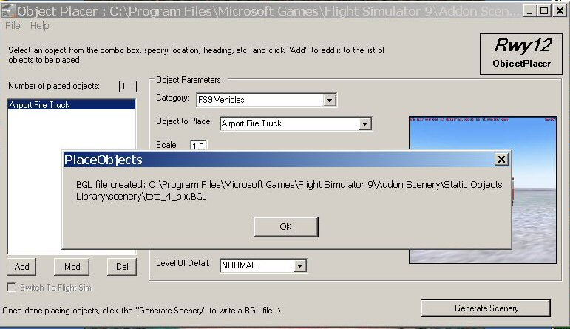

Note the location of your new bgl is specified as well as its name.

By default, the .xml and .bgl files will be placed in your Static Objects Library/Scenery folder – remember, that is the one you “activated” in step 9.

To verify all this, you can go to that folder using the new shortcut you created – the .xml and .bgl files you saved should appear in that folder.

Close RWY12 Object Placer and Close FS2004.

Restart FS2004 and go to the location where you added your object(s) and admire your handiwork!

Note: You may be wondering why I have suggested using the “save” or “save as” command after adding each object to the list instead of waiting until all objects had been added. If you have ever experienced a power failure or momentary electrical “hiccup” before you had saved an hour’s worth of work, you will understand. Saving frequently is just a safeguard against losing your work. If you should have to restart your computer due to a power failure, at least the majority of objects you had added would be stored in the xml file you had been working on and you can reopen this xml file and continue working.

Section E

Common Problems

The vast majority of problems that are reported on the RWY12 forum can be traced to the following situations:

a. Failure to copy the Static Object Library folder to Addon Scenery folder.

b. Failure to activate the Static Objects Library.

c. Failure to name the .xml files correctly - i.e. using spaces instead of underscores.

d. Failure to save the .xml and .bgl files to the Static Object Library / Scenery folder

Almost every problem could be traced to one or more of these items.

This is why the document you have just read stressed the importance of setting the program up correctly in the beginning.

That being said, here are just a few of the most often asked questions and answers.

Question: I see several versions of the RWY12 program on web sites – what are the differences?

Answer: Version 1.0 is the first release of the program. It contains all of the third party programs that are required to make the program work.

Version 1.1 comes in two forms. There is a full version that includes the additional library objects that were available at the time of release. It does not, however, include the third party programs. They must be downloaded separately.
The other Version 1.1 is only an update of the RWY12.exe file. It should be used by those who installed an earlier version and simply want to update it.

Be sure to carefully read the file description before downloading!

Question: What is the difference between a XML file and a BGL file?

Answer: In layman’s terms, a XML file is a text file which can be read using the Notepad program. Its layout is very specific and contains information regarding the objects ID number and its coordinates and other display data.

A BGL file is the resulting file that is created when a XML is acted upon by a program named bglcomp.exe. (This program is included in the RWY12 package). This converts the text based XML file into a format that can be read by FS2004. A BGL file cannot be read by mere mortals – only by the computer.

Question: Can the RWY12 program be installed anywhere other than on my C:\ drive?

Answer: Yes, the actual program may be placed on any drive or partition you desire. For new users however, it is recommended to place it on your C:\ drive. If you should place it elsewhere, be sure your shortcut to it reflects it’s proper location.

Question: When I place an object it shows up differently than I expected. Am I doing something wrong?

Answer: If you mean that the objects orientation is not what you expected, please re-read the Tutorial that came with the program. Most, but not all objects are oriented as your placement aircraft is. The jetways are not and a few other designers who have contributed their objects have made their object’s orientation slightly different also. With a little experimenting you will soon learn the orientation of the objects you use most often.

Question: I placed an object and went to the airport but I don’t see it. What’s wrong?

Answer: Did you close FS2004 and restart it again? You must do this as RWY12 is not a WYSIWYG (what you see is what you get) program. You are creating a new BGL file that FS2004 must index before it can be used. On average it only requires 1 to 1 ½ minutes to restart FS2004 again.

Question: Ok, I saved my XML file – how can I be sure it was saved in the Addon Scenery/Static Objects Library/Scenery folder?

Answer: At the top of the “save as” dialogue is a drop down menu tab that will allow you to “browse” your computer and select the folder you wish to save to. The following screenshot shows that dialogue.

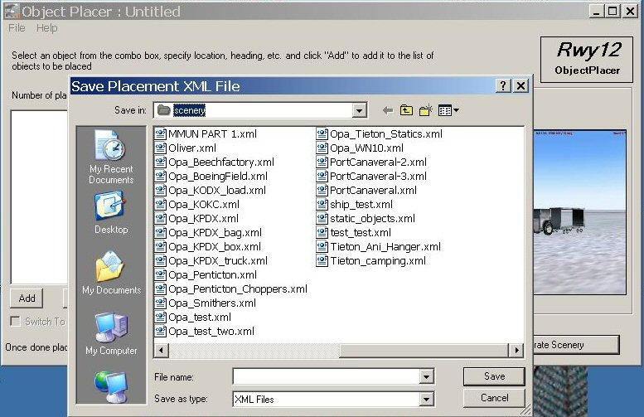

Note there is also a icon in the shape of a folder with an arrow pointing upwards on it. That tab can be used to back out level by level to confirm placement also. Just be sure that you end up with the “Save in” portion saying “scenery”. Also be sure to name your file correctly as detailed in Section D of this document. This is vital!

Question: I added some jetways but they are not lined up with the terminal. What can I do?

Answer: In Section G, there is a reference to an Illustrated Tutorial that will make the placing of jetways very simple and accurate. Please refer to that section.

Question: If I add an object and am not happy with its placement do I need to delete it and start all over?

Answer: No, you can easily change its placement simply by placing your aircraft in a better position, highlighting the object in question in the list and choosing the Sync FS position tab. Then hit “mod” and the program will modify the original information associated with that object. Be sure to use the “save” or better yet the “save as” option before regenerating the scenery bgl file or your changes will not be recorded.

Question: Can I add more objects to an existing BGL file?

Answer: Yes. Just use the File / Open dialogue to open the associated XML file. After it is opened you can add, modify or delete any objects it contains. When you are finished be sure to resave it before regenerating the scenery BGL file.

Question: Just what does the FSUIPC module do?

Answer: This module allows RWY12 (and many other addon programs) to communicate directly with FS2004 to obtain information such as coordinates, headings and so forth.

Question: I have seen some downloads where the author asked me to install the Rwy12 library and texture files again which I already have on my PC. In some cases they even ask me to install them in the scenery add-on folder, so now I have them installed twice. Is this allowed and can there be a conflict because of the double installation?

Answer: An excellent question! Unfortunately those who share their enhancements do not seem to be following the suggestions outlined in the RWY12 Tutorial. Some who share assume you have the RWY12 program and all current libraries installed and therefore only include their bgl enhancements. Others go the “extra mile” and provide setups for those who do and those who do not have RWY12 installed.

This “variety” of enhancement packages can be very confusing, however the following guidelines may be of help.

Always unzip any scenery enhancement you may download to a temporary folder. This will give you an opportunity to examine the author’s installation instructions and view the contents of any folders which are included.

The RWY12 library and texture files that may be included in a downloaded enhancement should be added to the Static Objects Library / Scenery and /Texture folders only. If they are already present they may be overwritten or ignored. You should not have a duplicate installation of the library BGL files as this may cause a conflict. Textures may be duplicated but that just wastes disk space.

Other BGL’s that the author included will be specific to the airport or area that has been enhanced and the names will likely reflect that.

These BGL’s may be placed in any “active” scenery folder but most often you will be instructed to put them in their own scenery folder or in your addon scenery/scenery subfolder. An example of “their own scenery folder” would be:

Any City USA ⬅ name of the scenery folder
scenery ⬅ scenery subfolder where the BGL’s would be placed

Note: A texture subfolder is not required in the above example as the textures are already on your hard drive – in the Static Objects Library/Textures folder.

Read the installation instructions carefully to determine just what the author has provided and how best to add the enhancement to your setup.

Many authors are now including their xml files in the downloaded package. This allows you to modify their work if you so desire. In this case, it is often better to place these xml and the associated bgl files in your Static Objects Library/scenery folder. Why? If you modify the xml files, that is where the regenerated bgl files would be placed by the RWY12 program.

So the bottom line is this:

You should not have a duplicate installation of the library bgls (they normally will start with the word “add”). Examples of these would be: add_balloons.BGL, add_Todd_Lucas_Tents.BGL, and add_SeevKahn_Trees.BGL. These should reside only in the Static Objects Library/Scenery folder.

Textures may be duplicated but there is no good reason to do so.

Where you place the scenery bgls will, to some extent, depend upon what method you use to keep your addon scenery organized. It is possible to dump everything into your addon scenery/scenery folder but most users elect to use a system which adds airports or areas that are activated individually as per the “Any City” example shown above.

Question: What is the difference between a library bgl and a scenery bgl?

Answer: A library bgl is a bgl file which contains a specific “library” or grouping of objects along with information regarding which textures each object will use and other data relative the items in this particular library. An example of this would be the library file which is named add_balloons.BGL. Within this file are all of the balloon models and the information noted above.

A scenery bgl file will store only the data necessary to select the proper item from the specified library (by means of a unique identification number) as well as information regarding how that item will be displayed and where – i.e. the coordinates. Using the example above, a scenery bgl might specify which balloon or balloons are to be displayed as well as their size and coordinates.

An analogy that might make this concept a bit clearer is to think of this in terms of a kitchen. You have a pantry shelf full of potential ingredients – the library bgl. You also have a recipe – the scenery bgl - which tells which ingredients to select from the pantry shelf and in what quantities to use them. And of course you have a cookbook which contains all of the recipes – the RWY12 Object Placer program.

Question: Wow, this sounds like the learning curve is very difficult – is it?

Answer: We believe most users who have tried the program would agree that the RWY12 Object Placer program is by far the easiest program of its kind to learn to use. It just takes a little patience and common sense.

Section F

Adding New Libraries

Question: I downloaded a new library of objects. How do I install them so they will be available to the RWY12 program?

Answer: It is probably best to first take a quick look at the structure of any properly prepared library.

It will include a folder with thumbnail images – the images you see when selecting an item in the RWY12 program. The folder with these images will have a name that usually suggests its contents; for example - Hot Air Balloons - S. Kahn.

The structure will also include an xml file – example; add_Balloons.xml.

There will also be a “library bgl” - example; add_Ballons.bgl

And there will be a set of textures relating to the library items.

Most creators of libraries will provide two zipped files; one that may be unzipped directly to your Static Objects Library and one that can be unzipped directly to your RWY12 program folder. If they have prepared everything correctly, the files contained in each zip will be placed correctly if you have used the “folders” option when unzipping.

If you are not comfortable doing this (errors in preparation of such zip files have been know to happen) then unzip everything to a temporary folder. You can then copy and paste the folders and files into their proper locations.

The folder with the thumbnail images should be copied to your RWY12/img folder. You should see other folders with thumbnail images in them in the img folder.

The xml file is to be copied to your RWY12 folder. Again you should see other xml file in that folder.

The library bgl file should be copied to your Static Objects Library/Scenery folder.

And finally, the textures should be copied to your Static Objects Library/Texture folder.

When you have done all of this, your new library will be available as a selection in your RWY12 Object Placer program.

Section G

Here are some useful RWY12 resources

1. You can always find help on the Rwy12 forum pages.

http://www.rwy12.com/portal/

Many knowledgeable users frequent the forums (including several who have contributed to this document) and they are almost always willing and able to provide assistance.

2. To aide you in placing jetways, the following Illustrated Tutorial which is available at Avsim.com will show you how to accomplish this quickly and accurately.

jetways_tutorial.zip - written by David Marshall

3. If you wish to learn the proper way to create a “library” which can be added to the Rwy12 program, the following Illustrated Tutorial is available at Avsim.com.

rwy12_tutorial.zip - written by Stephen Legg.

4. To easily monitor the availability of additional libraries and updates to the RWY12 program, create a shortcut on your desktop and paste the following data into the “location” window.

http://library.avsim.net/search.php?CatID=fs2004sd&SearchTerm=rwy12&Sort=Added&ScanMode=0&Go=Change+View

Name the shortcut “RWY12 at Avsim”. This shortcut will take you to the Avsim.com website and will immediately display all RWY12 related files, sorted by date.

This way you can easily determine if your version of the program is the latest available and if you have all of the object libraries. (Additional object libraries are being added virtually every month)

Note: This shortcut will only work at the Avsim.com website as Avsim does not require a “manual” login. In fact Avsim suggests that you not logout when you have finished your visit – just disconnect from the website.

This document was compiled in conjunction with the RWY12 team by David “Opa” Marshall.

Contributors include Gary Mills, Charles “Ebenezer” Mc Millan, Israel Roth and Seev Kahn.

